CPU Questions

1. Label the diagram below



**Key**

A- Level1 cache

B- Level 2 cache

C- Control unit

D- ALU

E- Registers

F- Level 1 cache

1. What are the advantages and disadvantages of Cache memory?

Advantage is that it is extremely fast and a disadvantage is it very expensive to produce.

1. Describe the differences between the three types of Cache Memory

There are 3 levels of cache memory they vary in speed and size.

1. Match the parts of the CPU on the left to what they to on the right

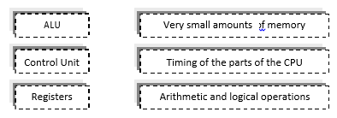

1. Match the units on the left to the their meaning on the right

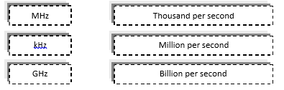

1. A processor states that it is dual core. How many cores does it have?

The processor has 2 cores.

1. For each description below name the part of the CPU that they describe
   1. A type of memory on the processor that stores only a few bytes of data for each one.

Cache memory

* 1. Responsible for arithmetic and logical operations

ALU unit

* 1. Needed to coordinate timing and data flow in the processor

Control unit

* 1. An intermediate type of memory between registers and RAM

ROM memory

1. A dual core processor has a speed of 1.7GHz. How many operations can it carry out per second?

1.7GHz x 2 = 3.4HGz per second

1. Write out and complete the text below:
   1. A CPU will make use of very small areas of memory called registers which operate at the same speed as the processor. The CPU can also read from, and write to, RAM. This operates at a GHz speed. Processors can also contain cache memory. This operates at a speed that is faster than RAM. By increasing the amount of cache, a computer will work faster as it will have to make fewer accesses to RAM.
2. A CPU that contains more than one core is known as what type of processor?

Multi core processor

1. What are the names given to CPUs with six cores? Eight cores?

6-core processor hex core 8-core processor octa core

1. Comparing 2 processors:

**Intel Core i3-4130T** processor has: dual core, operates at 2.9 GHz, its level 3 cache memory operates at 3MB and has 64 bit support. It has a price of £77.00

**Intel Core i7-5960X** processor has: 8-core operates at 3.0 GHz, its level 3 cache memory operates at 20MB and has 64-bit support. It has a price of £684.99

The reason that the **Intel Core i7-5960X** processor is more expensive then the **Intel Core i3-4130T** processor is because it has more processor cores, the processors also works at a faster speed and it has more cache memory.